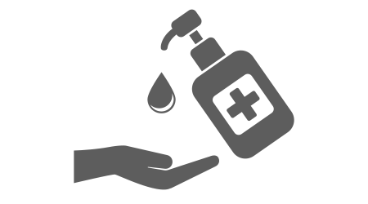
Protect Yourself and Your Loved Ones From COVID-19
Greater New York Health Care Facilities Association

COVID-19 VISITOR GUIDANCE

Wash your hands thoroughly with soap and water for at least 20 seconds or use Alcohol Based Hand Sanitizer that contains at least 60% alcohol.
- Avoid close contact with people who are sick and stay home if you are sick.
- You must wear a face mask or face covering in public when social distancing is not possible.
- Avoid touching your eyes, nose, and mouth.
- Remember to maintain social distancing precautions of at least 6 feet.

Visitor Guidance
- Visitors must sign in and will be screened for signs and symptoms of COVID-19 prior to the visit.
- Visitors must wear a facemask or face covering and will be provided a mask if they do not have one.
- Hand sanitizer will be used before and after the visit and as needed.
- There will be no more than 2 visitors per session.
- Visitors must have a Negative COVID test within 7 days of visiting (from the date test was performed).
- If any visitor fails to adhere to the protocol, he/she/they will be prohibited from visiting for the duration of the COVID-19 state declared public health emergency.

Note: Test results for Visitors will be required as of 9/24/20 in accordance with NYSDOH guidance.

If you have questions, please contact _______________________________

