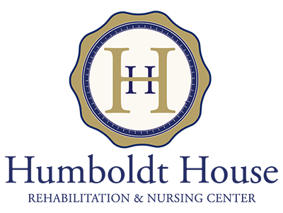
VISITATION FACT SHEET
In accordance with:
- CDC
- NYS DOH
- CMS

The hours of visitation are 9 AM – 4 PM M-F days a week. Weekends can be arranged as needed.

- ALL visits MUST be scheduled with ___________________________________________
- Visitors under the age of 18 must be accompanied by an adult 18 years of age or older.
- Only 2 visitors at a time
- Visitor screen sheet MUST be completed and include the following:
  - Signs and Symptoms of COVID
  - Temperature
  - Screening questions to include potential exposure to COVID and recent travel locations both international in within the US.
- The visitor MUST complete an information identification form to include:
  - Resident visited
  - First and last name of the visitor;
  - Physical (street) address of the visitor;
  - Daytime and evening telephone number;
  - Date and time of visit;
  - Email address, if available
- Visitation will be refused if the individual(s) exhibits any COVID-19 symptoms, does not pass the screening questions or does not comply with completion of visitor screen.
- Current COVID-19 positive residents, residents with COVID-19 signs/symptoms, and residents in a 14-day quarantine or observation period are not eligible for visits.
- The visitors must:
  - Wear a face mask or face covering which covers both the nose and mouth at all times when on the premises of the NH.
  - Maintain social distancing, except when assisting with wheelchair mobility. The nursing home must have adequate supply of masks on hand for visitors and must make them available to visitors who lack an acceptable face covering.
- If any visitor does not adhere to the DOH/nursing homes’ protocol, the visitor will be prohibited from visiting for the duration of the COVID-19 state declared public health emergency.

Thank you for helping us keep our residents happy and healthy.

